GLOBAL GROUP OF INSTITUTIONS

GAME ON:-

Day of birth day

BCA 5th SEMESTER(2017-2020)

Under

Maulana Abul Kalam Azad University

Group -C

Bca 5th sem

GAME

* Submitted by
* Raine Paul (g.l)
* Tanmay Singha (asst. g.l)
  + - * Payel Goswami
      * Sumita Bera
      * Sriparna Sarkar
      * Mahadev Maithy
      * Anushree Kamila
      * Souvik Roy
      * Rhitam Adak

***Acknowledgement***

I along with my group members are very thankful and privileged to get an interesting game where we have to find about our day of birth… ….

It was really very interesting and it was also an wonderful experience for us. Thank you teachers for giving us this topic

**Index**

* **Introduction**
* **Game profile**
* **Game objectives**
* **Game technology overview**
* **Conclusion**

GAME PROFILE-

A “game ”in game theory is a fully explicit structure which characterizes each player’s set of actions, payoffs and possible out comes under given rules of playing.

Like that only we have also made a tricky game.

A game is a structured from of play, usually undertaken for enjoyment and sometimes used as educational tool…

**Game Objectives**

* **It is a new game to all of us.**
* **It is a very interesting game.**
* **Through this game, those who are playing will enjoy a lot**

**Game technology overview**

We have used here c programming language.

C Is highly portable and is used for scripting system applications which form a major part of windows, Unix, and Linux operating system. C is general -purpose programming language and can efficiently work on enterprise applications ,games graphics ,and applications requiring calculations, etc.

C is a structured programming language which allows a complex program to be broken into simpler program called functions. It also allows free movement of data across these functions.

Coding:-

#include<stdio.h>

#include<conio.h>

void main()

{

int ch,date,year,ans;

clrscr();

printf("choose number between 1 to 7");

printf("\n Enter your date of birth:");

scanf("%d",&date);

printf("\n Enter your last two digits of your birth year:");

scanf("%d",&year);

printf("\n Do the instruction\n");

getch();

printf("\n Multiply the choosen number with 2\n");

getch();

printf("\n Add your birthdate with your answer\n");

getch();

printf("\n Substract between your answer and last two digits of your birth year\n");

printf("\nEnter the Final Answer:\t");

scanf("%d",&ans);

if(year>=ans)

{

ch=(((year-ans)-date)/2);

}

else

{

ch=(((year+ans)-date)/2);

}

switch(ch)

{

case 1:

printf("\nYour birthday is SUNDAY");

break;

case 2:

printf("\nYour birthday is MONDAY");

break;

case 3:

printf("\nYour birthday is TUESDAY");

break;

case 4:

printf("\nYour birthday is WEDNESDAY");

break;

case 5:

printf("\nYour birthday is THURSDAY");

break;

case 6:

printf("\nYour birthday is FRIDAY");

break;

case 7:

printf("\nYour birthday is SATURDAY");

break;

default:

printf("\nWrong Choice");

break;

}

getch();

}

  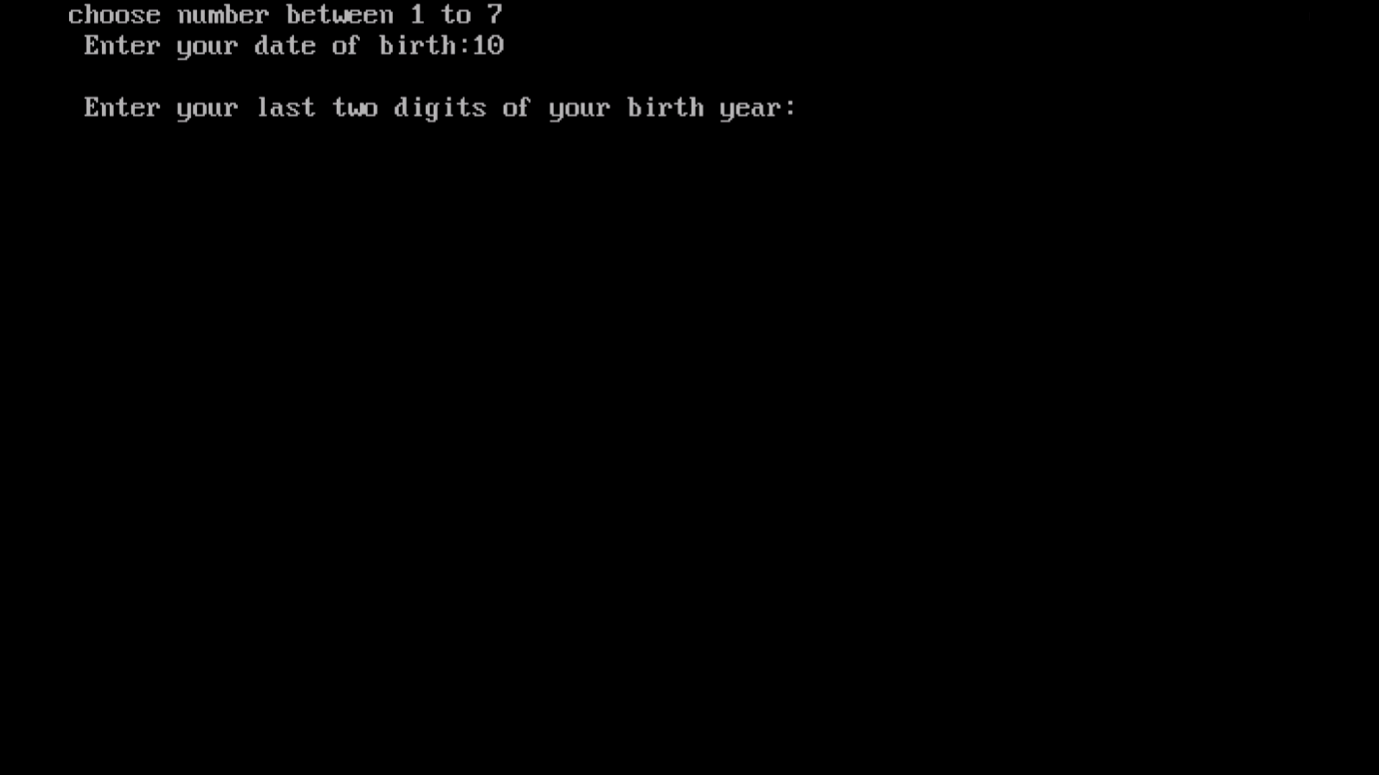 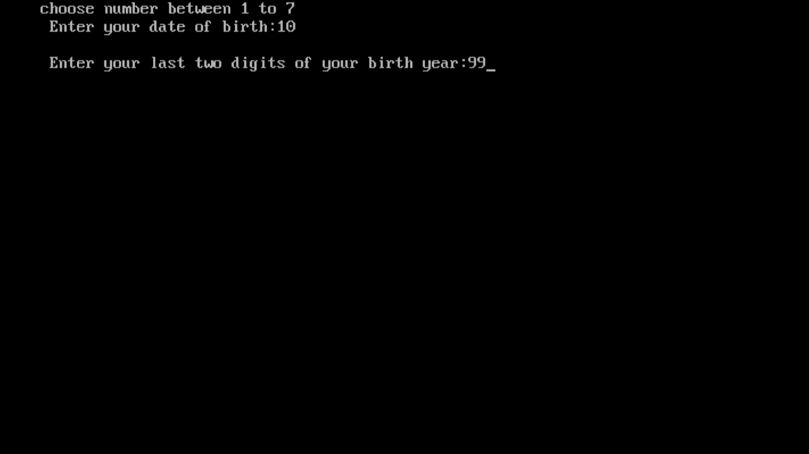 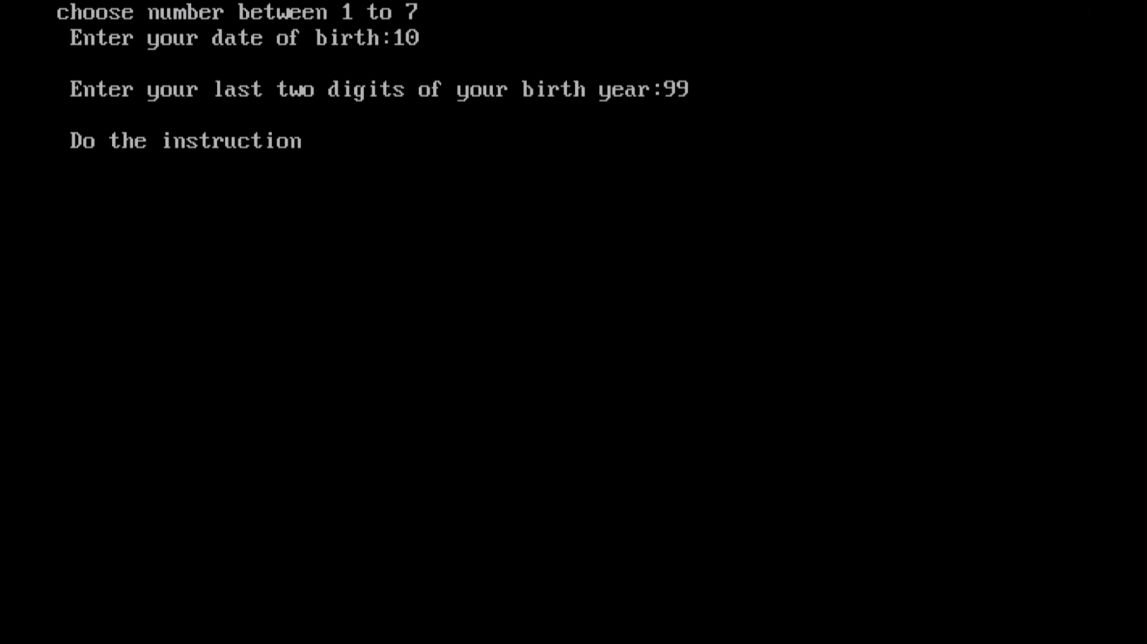 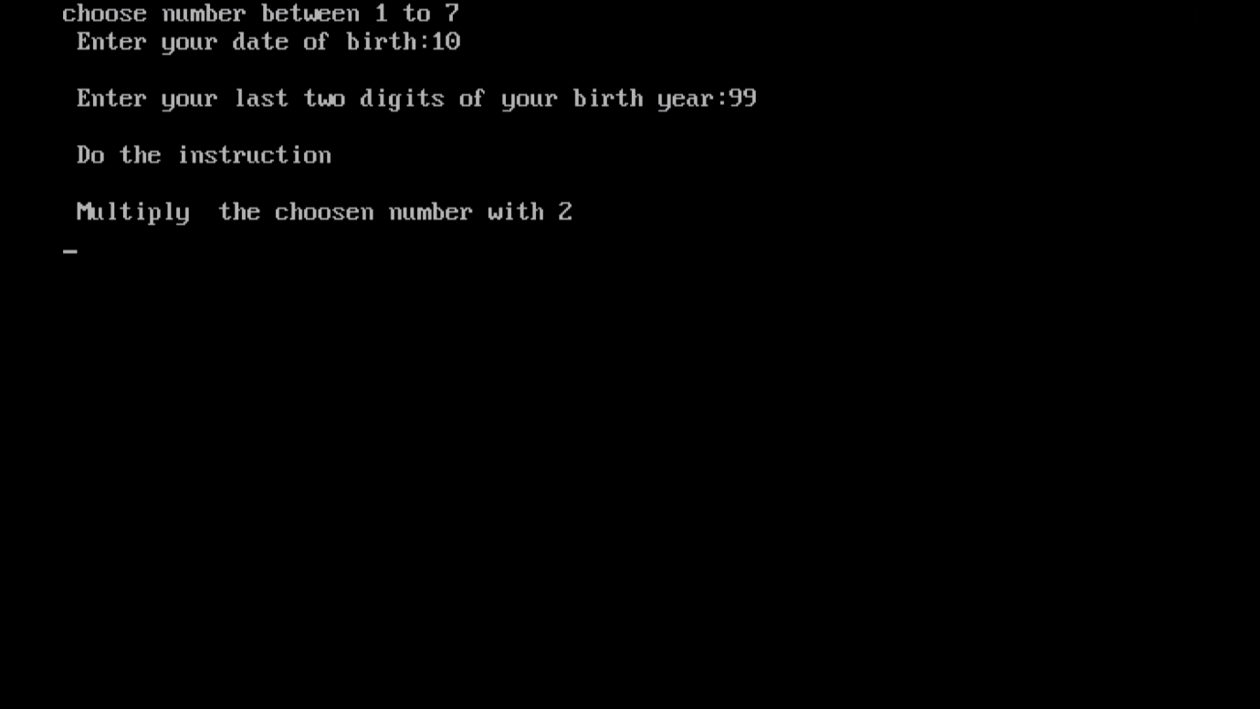 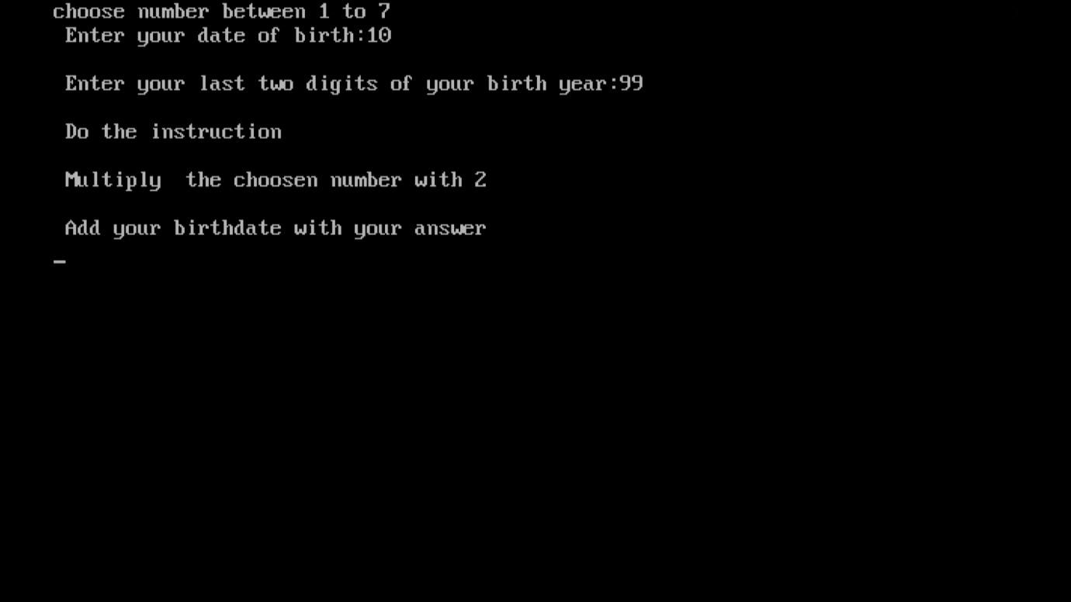 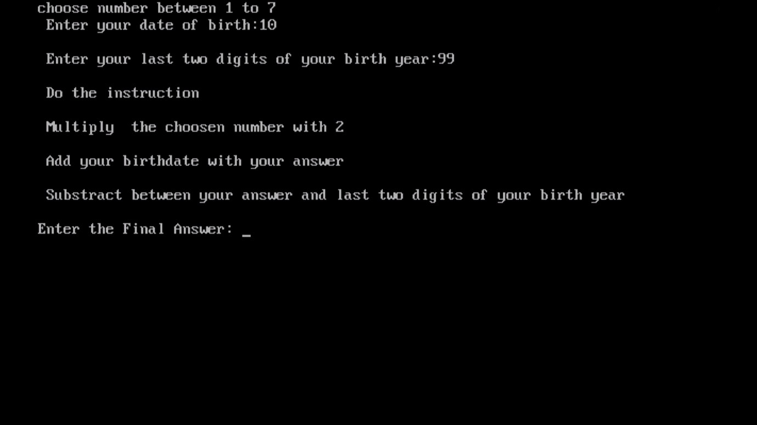 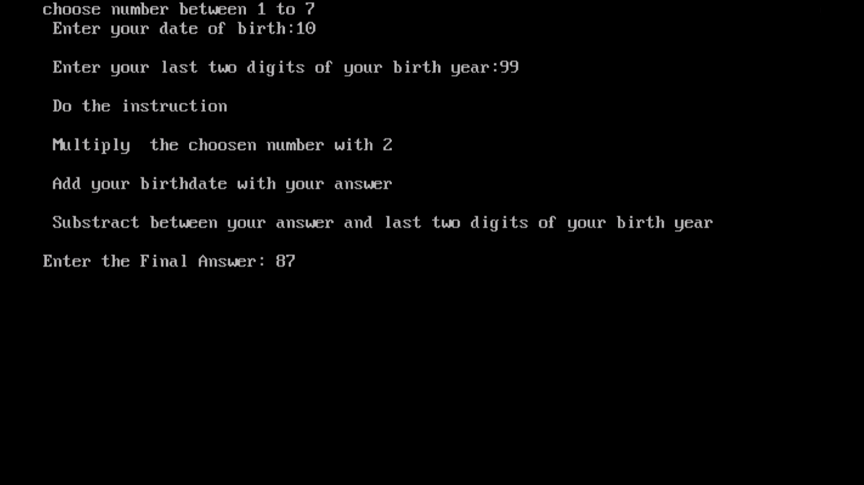 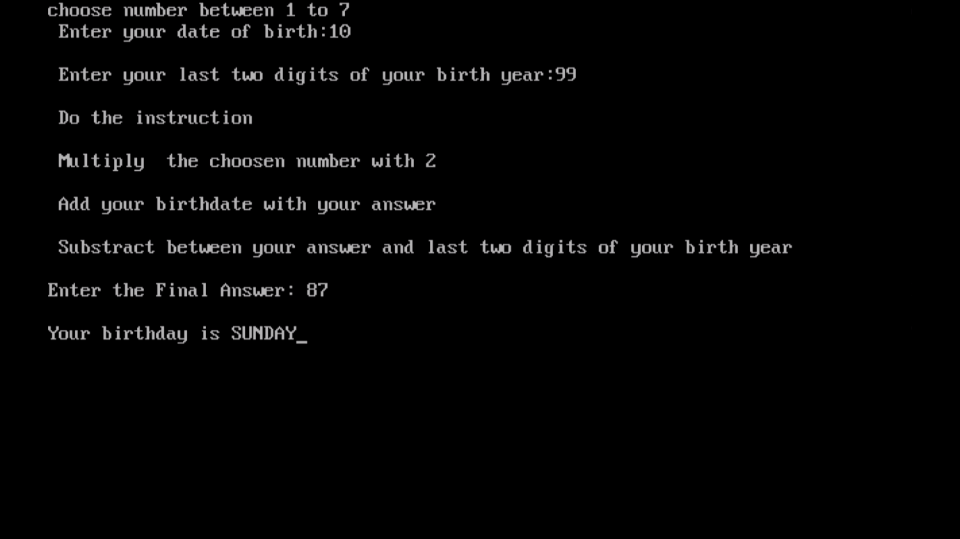

**Conclusion**

Game choice should involve careful consideration of related theoretical context relevant to curriculum and learning out comes. There should be clear tangible learning objectives with tasks suitable supporting students in developing specific skills and knowledge.